|  |  |
| --- | --- |
|  | **Cognizant Academy**    **LearnToday**    **FSE Web API Specification Document**    **Version 1.0** |
| |  |  |  |  | | --- | --- | --- | --- | |  | **Prepared By / Last Updated By** | **Reviewed By** | **Approved By** | | **Name** |  |  |  | | **Role** |  |  |  | | **Signature** |  |  |  | | **Date** |  |  |  | |
|  |

**Table of Contents**

1. Introduction
2. Purpose of this document

The purpose of this document is to define the user interface specification for LearnToday project.

1. Definitions & Acronyms

|  |  |
| --- | --- |
| **Definition / Acronym** | **Description** |
|  |  |

1. Project Overview

LearnToday is an online training application which allows students to view all the courses and allows them to enroll for the courses. It also allows trainer registration and signin actions.

1. Scope

Develop LearnToday application web services using Web API.

1. Intended Audience

* Product Owner
* Scrum Master
* Application Architect
* Project Manager
* Test Manager
* Development Team
* Testing Team

1. Hardware and Software Requirement
2. Hardware Requirement:
3. Developer Desktop PC with 8GB RAM
4. Software Requirement
5. Visual studio 2017
6. Chrome Browser
7. Postman tool
8. Forking and Cloning

**Fork project:**

1. <https://code.cognizant.com/dotnet/LearnToday-WebApi>

* 1. LTUC001

**Create  ‘Course’ as business entity**

1. Add an ADO.NET Entity data model for connecting SQL database to get course data.
2. This data would be used for all types of users master data

3.2 LTUC002

**Create New AdminController**

1. This controller is for Admin person of the application to view and edit course detail.
2. Have GET action method, without parameter that invokes the course listing method of Course class to get all the course details.

The below is a sample for showing the course details in Get action result.

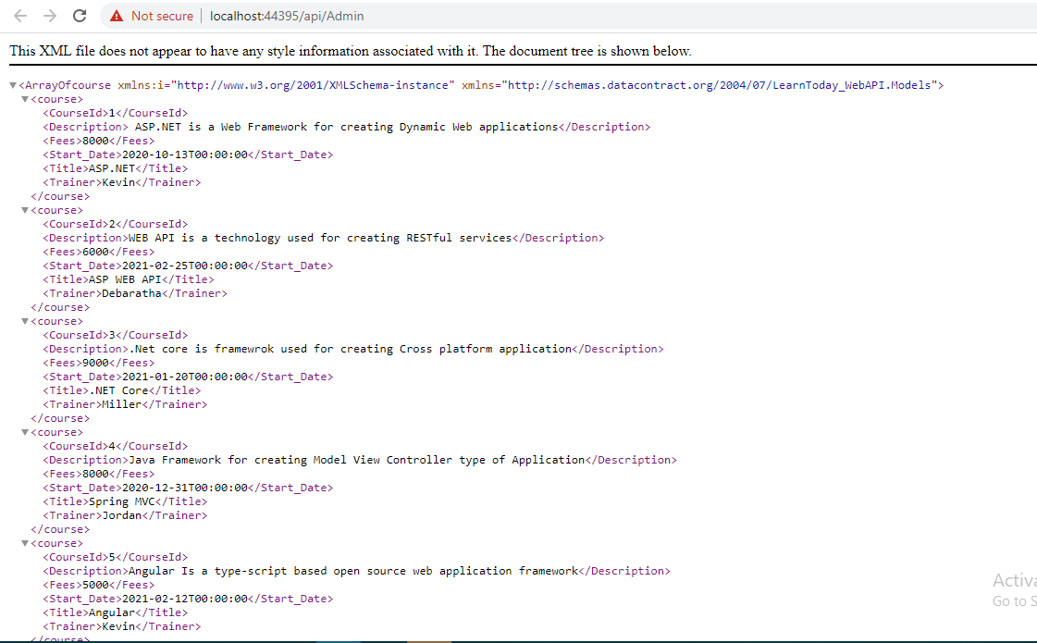

3.3 LTUC003

* 1. Have PUT action method that takes in the course id as a parameter in the Admin Controller. The course detail will be sent as data in the body. This is to be extracted and the master data needs to be updated. The method should return HttpStatusCode for Ok if updated, or HttpStatuscode for Notfound and should return Course id not found.

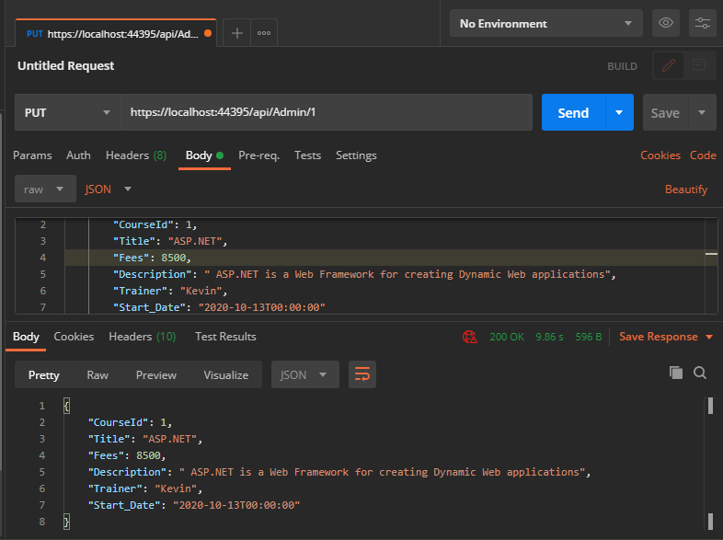

Httpstatuscode

If the course id is Not found

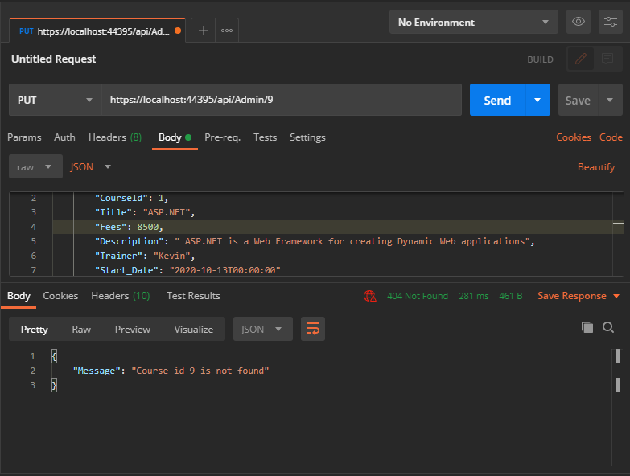

3.4 LTUC004

**Create New StudentController**

1. This controller is for student to view and enroll for a course.
2. Have GET action method, without parameter that invokes course listing method of Course class to get all Courses. Filter the list for course training start date in future .

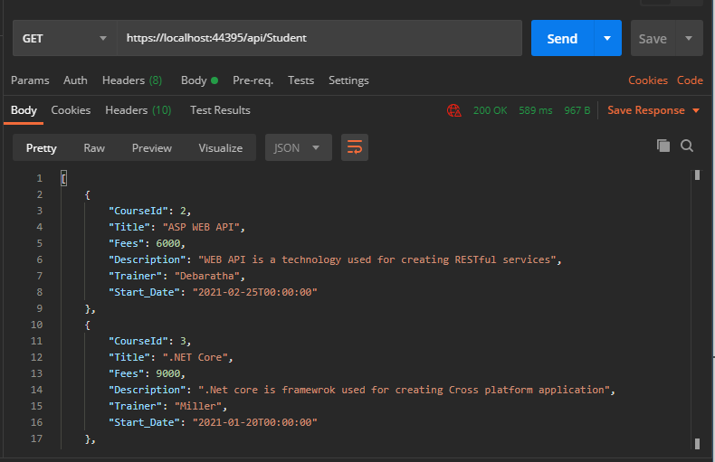

3.5 LTUC004

* 1. Have POST action method to enroll student for the course. Input studentcourse by using FromBody attribute. Return HttpStatusCode for created .

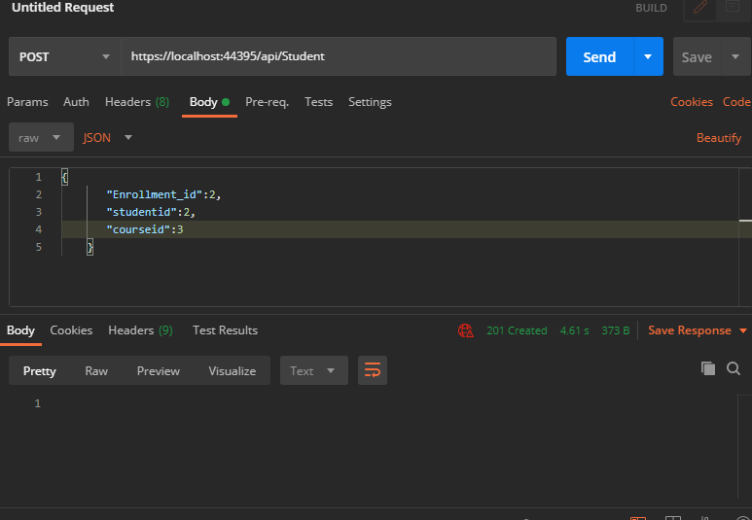

3.6 LTUC004

1. Have DELETE action method to remove the course id that was enrolled by the student using the enrollment id. Return HttpStatusCode for OK.

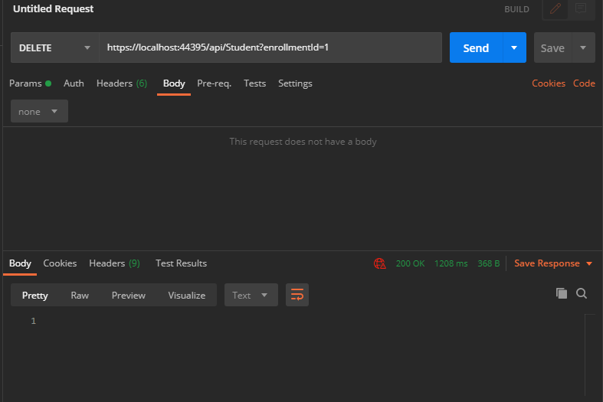

4. LTUS001 & LTUS002 – Signup Trainer & Login

**Create New Trainer entity**

1. Create a Trainer class for the business entity for trainer login and signup.

**Create New TrainerController**

1. The controller used for Trainer login and trainer signup.
2. Have POST action method to store the new trainer details to the database.

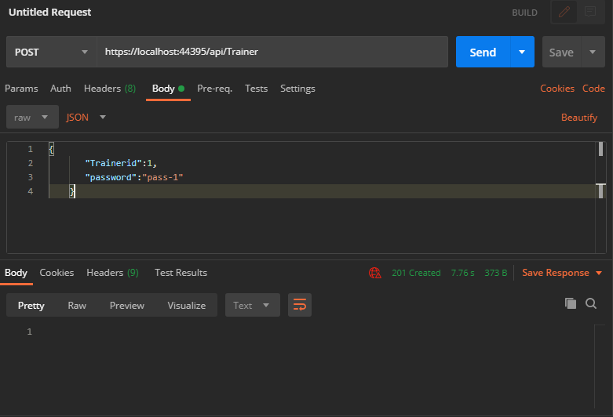

1. Have GET action method , with trainer id as parameter, take the trainer password in the request body.Fetch the trainer list from database and check if the trainer id and password matches. Return Httpstatuscode for OK , else return Httpstatuscode for NotFound .

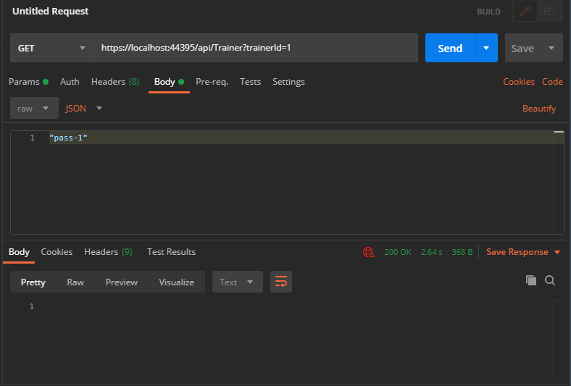

**If trainer id is not found,**

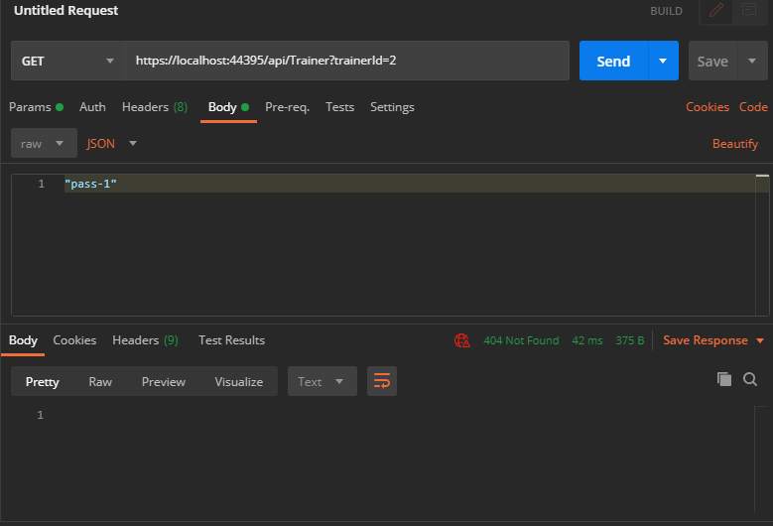

1. Code submission instructions

Use git add, commit and push commands to upload your code into remote GltLab repository.

During commit, give the commit message as “WebApi”.

1. Change Log

|  |  |  |  |  |
| --- | --- | --- | --- | --- |
|  | **Changes Made** | | | |
| V1.0.0 | Initial baseline created on <dd-Mon-yy> by <Name of Author> | | | |
| Vx.y.z | <Please refer the configuration control tool / change item status form if the details of changes are maintained separately. If not, the template given below needs to be followed> | | | |
| **Section No.** | **Changed By** | **Effective Date** | **Changes Effected** |
|  |  |  |  |